**Education's Spark: Illuminating the Future of Africa**

**Introduction**

The sun rays glorifies a large platform for various histories and stories of people and land. Africa which is a continent of hope due to its youth and strength echoes with a rhythm like a jolly young person. Yet, the issue pacing below is that, however, girls in remote areas can still have an issue of having the quality education. This picture essay goes to the root of this battle, which is not only are the problems but also the never-quitting enthusiasm that hot the fire up [that keep the fire burning]. It is the saga whispered in between the turn of each page, manifested in steps that will not be slowed down, and the indication of the potential of a better future.



**A Spark in the Dimmest Light**

Let us picture a young girl in her youth, in her garments of darkness that the evening casts upon her. Her neighborhood is modest, it a mud house the only one she owns. Nevertheless, the flickering of the kerosene lamp highlights the peace on her face, and, at the same time, the book in her hand is seen as being brought almost to her chest. Her eyes, wonder-wide, are raw with hunger for those sentences, each one a spark that forges a flame within her. This picture conveys the craving for universality, or at least the idea of the quest for knowledge that goes beyond boundaries.

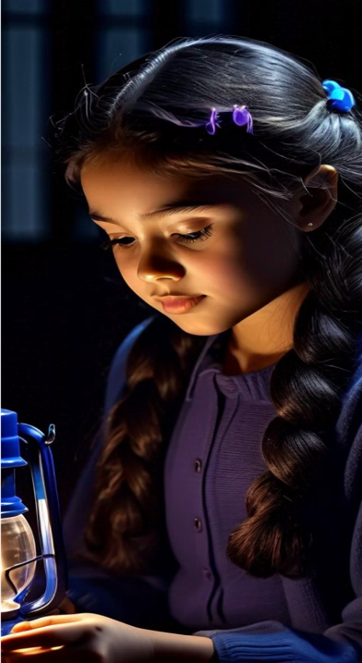

**The Long Walk to Learning**

Familyhood trail extends indefinitely, a strip of clay dust bearing west countercurrent to the massive sand dunes. Distant from, a small object seems, a young boy with description of a satchel, which is in a bad condition hangs on his shoulder. The form the way his jaw square just poured everything about his relentless tenacity. It is a painting that exhibits the day-to-day predicament that encounters numerous African kids, mainly the ones in the villages with low development. Education, since it's not a right but rather a privilege against trials and tribulations, is the key to socioeconomic mobility for them.



**The Overburdened Classroom**

Through the cracks of corrugated metal roof, sun rays wink and glitter of everything, while behind this shimmering scenery, the chaos of ordered confusion keep the site fully operational. The room is packed with expectant faces and high-pitched voices of young people. The youth symphony competes with the humming in every corner of the room. Herein lies a single teacher, at the same time, diligence displayed on their forehead, struggles with the constrain from the limited resources. It is in which their passion becomes a shining beacon amid this struggle. This picture symbolizes the pressure on existing infrastructure. Such an example demonstrates the degree of dedication shown by the educators who, in buckling under the overwhelming challenges, still fertilize the soil for knowledge.

**Beyond the Classroom Walls**

Education is no longer a classroom concrete activity; it can happen anywhere, anytime, and with anyone. Contemplate a small community of girls with arms around themselves, staying away from the blazing sun, under a great baobab tree. In colorful pieces of clothing, they feel happy and their playful laughter makes it so that their voices also tune in well together with the rustling trees so that stories are shared while problems can be solved. This picture demonstrates how by education we can build tolerance and take away detachment through cultures. When knowledge is thus acquired from a diversity of backgrounds, girls of different environments then become sisters of the similar determination to achieve a brighter tomorrow.

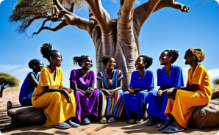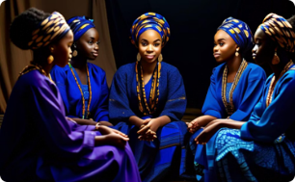

**The Ripple Effect of Empowerment**

The stage with eye-catching decors become a testimony to the importance of the occasion. A cap and gown are worn by a woman of a young age. She is standing tall with confidence, her dazzling smile painting her face in joy. In her hand, she is holding a diploma she has earned the hard way, the victory it symbolizes. This picture captures the transforming process of getting education. It makes people stronger, breaks the chain of poverty and creates a wave which can change the course of destiny of people and communities as well as nations.

**Building a Brighter Future, Brick by Brick**

The final scene of my mini-movie is a hectic construction site. The faces of the local people whose faces a range of determination appeared as they were handing out the new school bricks. It brings back all the memories that offer us motivation to become something better and allow us to visualize a brighter future. Educations, the same as its environments, is a collaborative job that requires every community's effort. In other words, putting money in education is like enrich the toolbox of conjugator and is also like listening to the summer breeze solution and guide the coming generation so that they will be educated.

**Conclusion**

Education is like the fire in a box which can illuminate the potentials of every African child. We build a corridor which leads us towards the future, the future that is bright, full of the something that we’ve seen at the beginning, the something that will counterbalance the negative traits of our current life. This paper constitutes a call to process, which, in fact, is a request to make an investment. The most valuable resource that Africa has at its disposal at the moment is its young minds. Launching the way does education include for girls is rural areas with beacon of hope not just for current generation but also for the generations to come.